CSA0604 – DESIGN AND ANALYSIS OF ALGORITHM

LAB PROGRAMS

NAME:ABZAM.A
REG NO : 192573029

1. First Palindromic String
Code
#include <stdio.h>
#include <string.h>
int isPalindrome(char str[]) {
int i = 0;
int j = strlen(str) - 1;
while (i < j) {
if (str[i] != str[j])
return 0;
i++;
j--;
}
return 1;
}
int main() {
char words[5][20] = {"abc", "car", "ada", "racecar", "cool"};
for (int i = 0; i < 5; i++) {
if (isPalindrome(words[i])) {
printf("%s\n", words[i]);
return 0;
}
}
printf("No palindromic string\n");
return 0;
}

Test Case Outputs
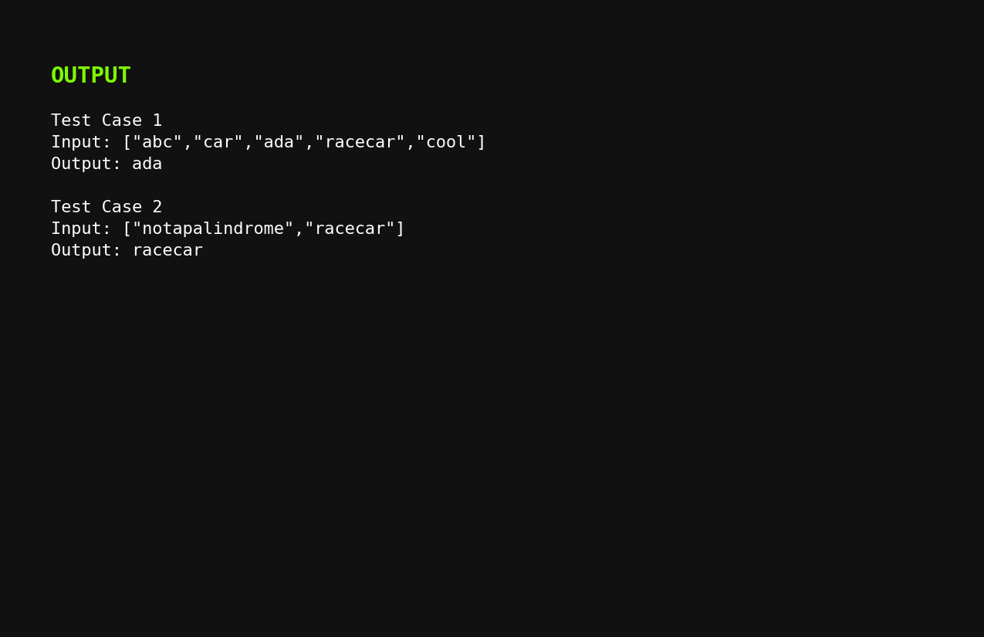

2. Count Elements Existing in Both Arrays
Code
#include <stdio.h>
int exists(int arr[], int n, int value) {
for (int i = 0; i < n; i++) {
if (arr[i] == value)
return 1;
}
return 0;
}
int main() {
int nums1[] = {2, 3, 2};
int nums2[] = {1, 2};
int n = 3, m = 2;
int answer1 = 0, answer2 = 0;
for (int i = 0; i < n; i++)
if (exists(nums2, m, nums1[i]))
answer1++;
for (int i = 0; i < m; i++)
if (exists(nums1, n, nums2[i]))
answer2++;
printf("[%d, %d]\n", answer1, answer2);
return 0;
}

Test Case Outputs
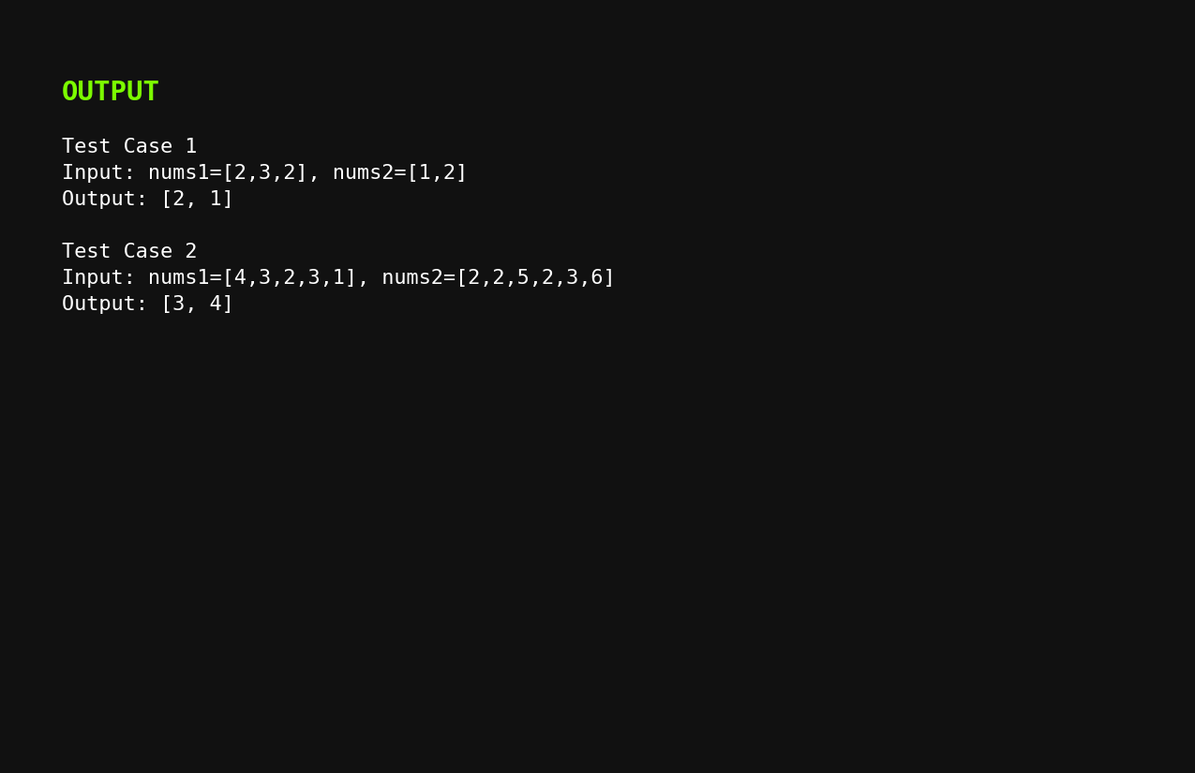

3. Sum of Squares of Distinct Counts of All Subarrays
Code
#include <stdio.h>
int main() {
int nums[] = {1, 2, 1};
int n = 3;
int answer = 0;
for (int i = 0; i < n; i++) {
int freq[100] = {0};
int distinct = 0;
for (int j = i; j < n; j++) {
if (freq[nums[j]] == 0) {
distinct++;
freq[nums[j]] = 1;
}
answer += distinct * distinct;
}
}
printf("%d\n", answer);
return 0;
}

Test Case Outputs
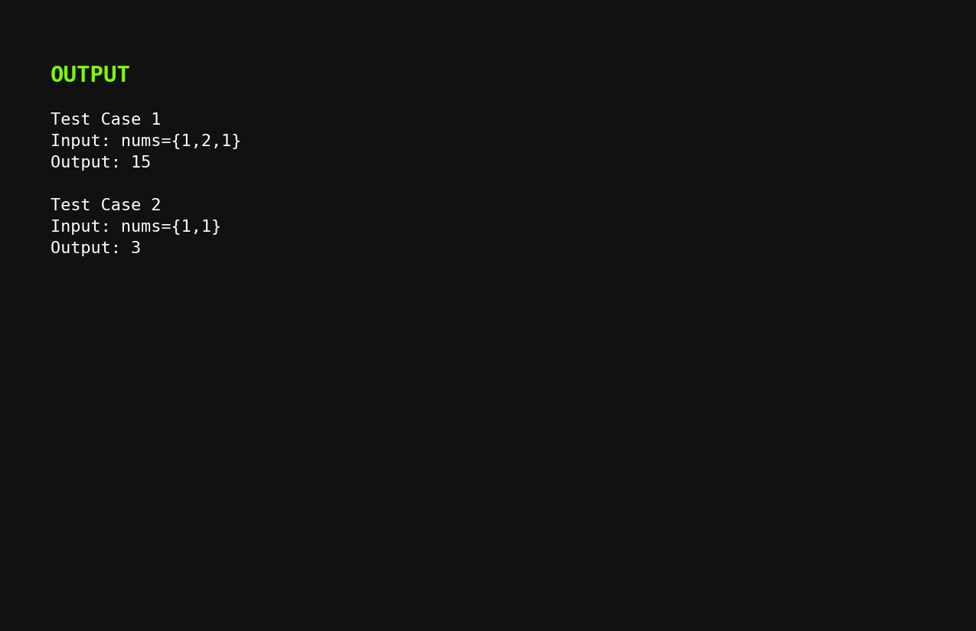

4. Count Equal Pairs with (i × j) Divisible by k
Code
#include <stdio.h>
int main() {
int nums[] = {3, 1, 2, 2, 2, 1, 3};
int n = 7;
int k = 2;
int count = 0;
for (int i = 0; i < n; i++) {
for (int j = i + 1; j < n; j++) {
if (nums[i] == nums[j] && (i * j) % k == 0)
count++;
}
}
printf("%d\n", count);
return 0;
}
Test Case Outputs
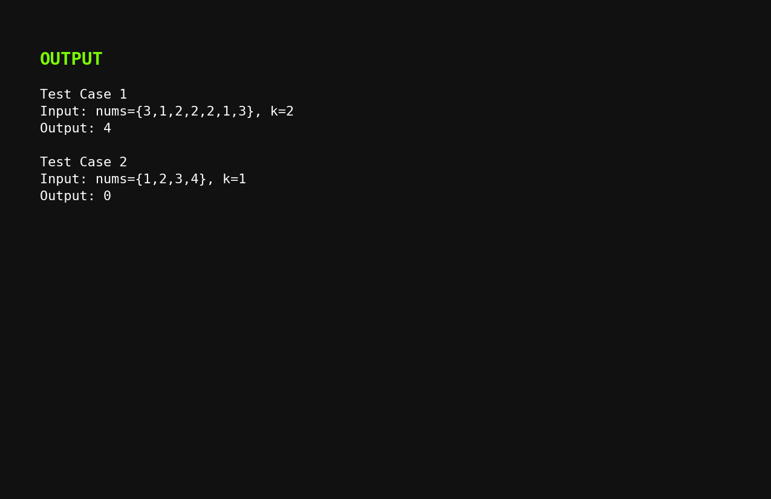

5. Find Maximum Element with Least Time Complexity
Code
#include <stdio.h>
int main() {
int nums[] = {1, 2, 3, 4, 5};
int n = 5;
if (n == 0) {
printf("List is empty\n");
return 0;
}
int max = nums[0];
for (int i = 1; i < n; i++) {
if (nums[i] > max)
max = nums[i];
}
printf("%d\n", max);
return 0;
}

Test Case Outputs
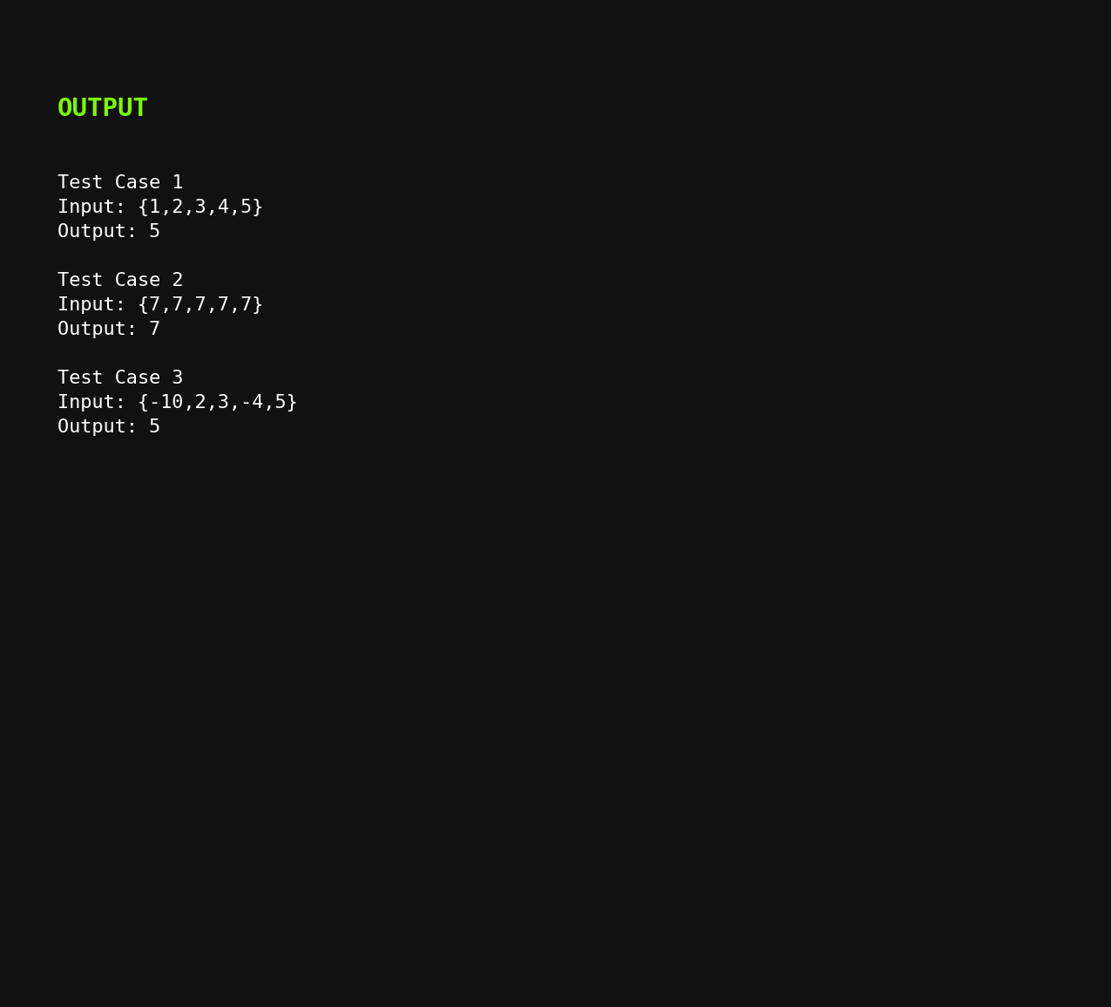

6. Sort Using Merge Sort and Find Maximum
Code
#include <stdio.h>
void merge(int arr[], int left, int mid, int right) {
int temp[100];
int i = left, j = mid + 1, k = 0;
while (i <= mid && j <= right) {
if (arr[i] <= arr[j])
temp[k++] = arr[i++];
else
temp[k++] = arr[j++];
}
while (i <= mid)
temp[k++] = arr[i++];
while (j <= right)
temp[k++] = arr[j++];
for (i = left, k = 0; i <= right; i++, k++)
arr[i] = temp[k];
}
void mergeSort(int arr[], int left, int right) {
if (left < right) {
int mid = (left + right) / 2;
mergeSort(arr, left, mid);
mergeSort(arr, mid + 1, right);
merge(arr, left, mid, right);
}
}
int main() {
int arr[] = {3, 8, 2, 10, 5};
int n = 5;
if (n == 0) {
printf("List is empty\n");
return 0;
}
mergeSort(arr, 0, n - 1);
printf("Sorted array: ");
for (int i = 0; i < n; i++)
printf("%d ", arr[i]);
printf("\nMaximum element = %d\n", arr[n - 1]);
return 0;
}
Test Case Outputs
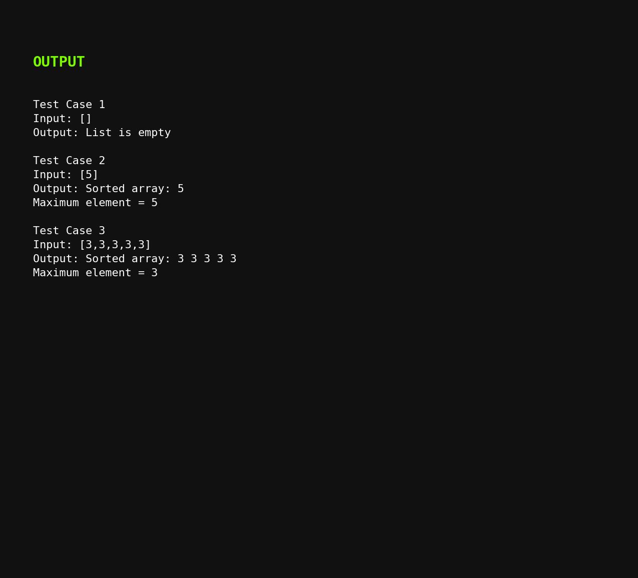

7. Find Unique Elements
Code
#include <stdio.h>
int main() {
int arr[] = {3, 7, 3, 5, 2, 5, 9, 2};
int n = 8;
int unique[100];
int count = 0;
for (int i = 0; i < n; i++) {
int found = 0;
for (int j = 0; j < count; j++) {
if (arr[i] == unique[j]) {
found = 1;
break;
}
}
if (!found)
unique[count++] = arr[i];
}
printf("Unique elements: ");
for (int i = 0; i < count; i++)
printf("%d ", unique[i]);
printf("\n");
return 0;
}

Test Case Outputs
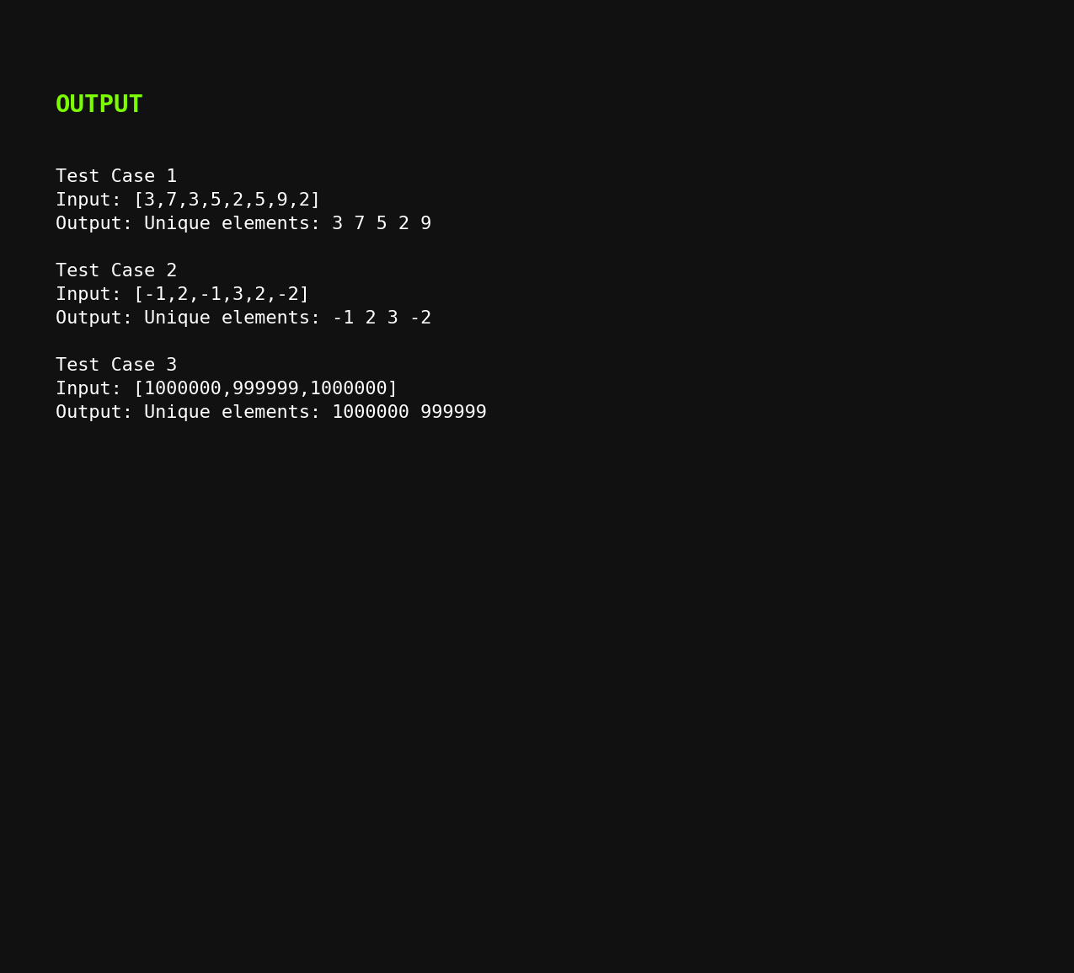

8. Bubble Sort
Code
#include <stdio.h>
int main() {
int arr[] = {5, 2, 8, 1, 3};
int n = 5;
for (int i = 0; i < n - 1; i++) {
int swapped = 0;
for (int j = 0; j < n - i - 1; j++) {
if (arr[j] > arr[j + 1]) {
int temp = arr[j];
arr[j] = arr[j + 1];
arr[j + 1] = temp;
swapped = 1;
}
}
if (swapped == 0)
break;
}
printf("Sorted array: ");
for (int i = 0; i < n; i++)
printf("%d ", arr[i]);
printf("\n");
return 0;
}
Test Case Outputs
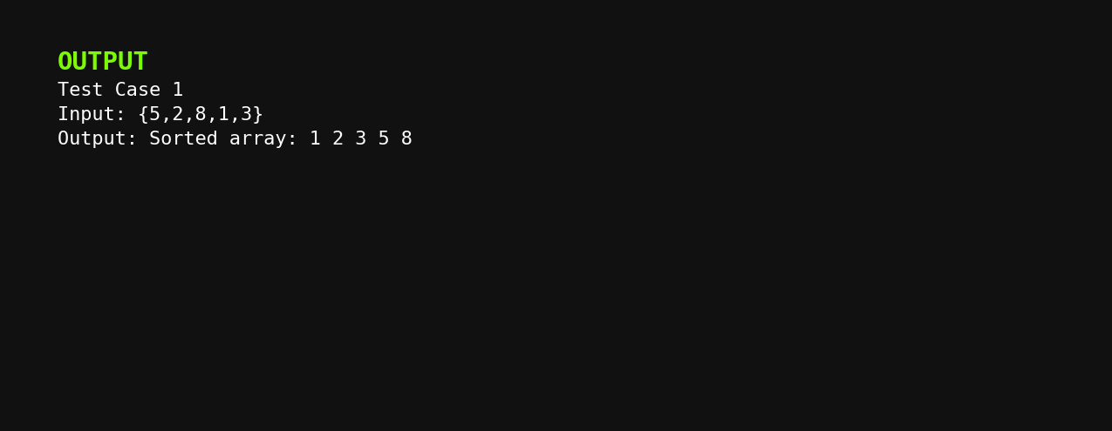

9. Binary Search
Code
#include <stdio.h>
int main() {
int arr[] = {-9, 3, 4, 6, 8, 9, 10, 30};
int n = 8;
int key = 10;
int low = 0, high = n - 1;
int found = -1;
while (low <= high) {
int mid = (low + high) / 2;
if (arr[mid] == key) {
found = mid;
break;
}
else if (arr[mid] < key)
low = mid + 1;
else
high = mid - 1;
}
if (found != -1)
printf("Element %d is found at index %d\n", key, found);
else
printf("Element %d is not found\n", key);
return 0;
}
Test Case Outputs
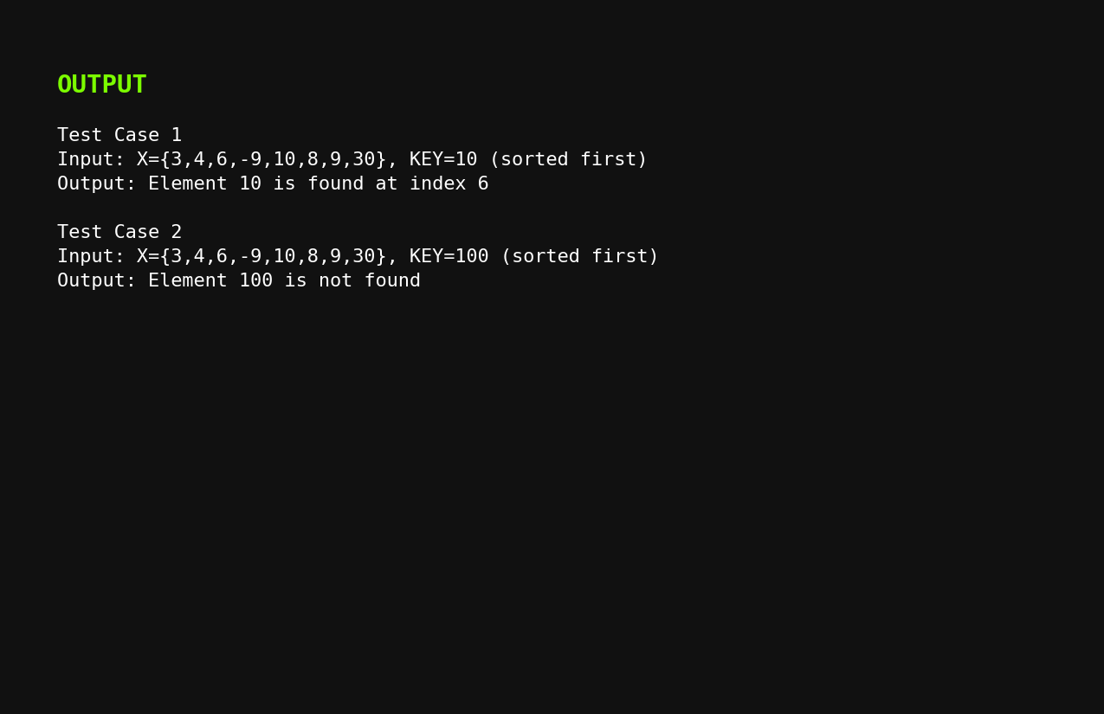

10. Sort Array in O(n log n) with Smallest Space
Code
#include <stdio.h>
void heapify(int arr[], int n, int i) {
int largest = i;
int left = 2 * i + 1;
int right = 2 * i + 2;
if (left < n && arr[left] > arr[largest])
largest = left;
if (right < n && arr[right] > arr[largest])
largest = right;
if (largest != i) {
int temp = arr[i];
arr[i] = arr[largest];
arr[largest] = temp;
heapify(arr, n, largest);
}
}
void heapSort(int arr[], int n) {
for (int i = n / 2 - 1; i >= 0; i--)
heapify(arr, n, i);
for (int i = n - 1; i > 0; i--) {
int temp = arr[0];
arr[0] = arr[i];
arr[i] = temp;
heapify(arr, i, 0);
}
}
int main() {
int nums[] = {5, 2, 8, 1, 3};
int n = 5;
heapSort(nums, n);
printf("Sorted array: ");
for (int i = 0; i < n; i++)
printf("%d ", nums[i]);
printf("\n");
return 0;
}
Test Case Outputs

